**Cyber security project team – 5**

BACHELOR OF TECHNOLOGY

in

CSE – CYBER SECURITY

submitted by

RAJULAPTI.BHAVANI (22B25A4601)

Student’s Declaration

I RAJULAPATI.BHAVANI a student of BACHELOR OF TECHNOLOGY program, Reg.No.22B25A4601 of the Department of CSE (CYBER SECURITY), KAKINADA INSTITUTE OF ENGINEERING AND TECHNOLOGY do hereby declare that I have completed the day 1 task (GIT COMMANDS AND BRANCH COMMANDS) on February 2025 15 under the guidance of MR. AJAY SIGIREDDY B.Tech, Department of CSE –CYBER SECURITY, KAKINADA INSTITUTE OF ENGINEERING AND TECHNOLOGY.

TABLE OF CONTENTS

ACKNOWLEDGEMENT.

1. Creating folder
2. Creating file
3. Opening terminal
4. Git initialization
5. Adding file to git
6. Adding new line to file
7. Create a branch
8. Extablish a connection between git and github repsotiry

Creating Folder

Create a new folder so that the files will be stored in the folder. That folder will connect with git

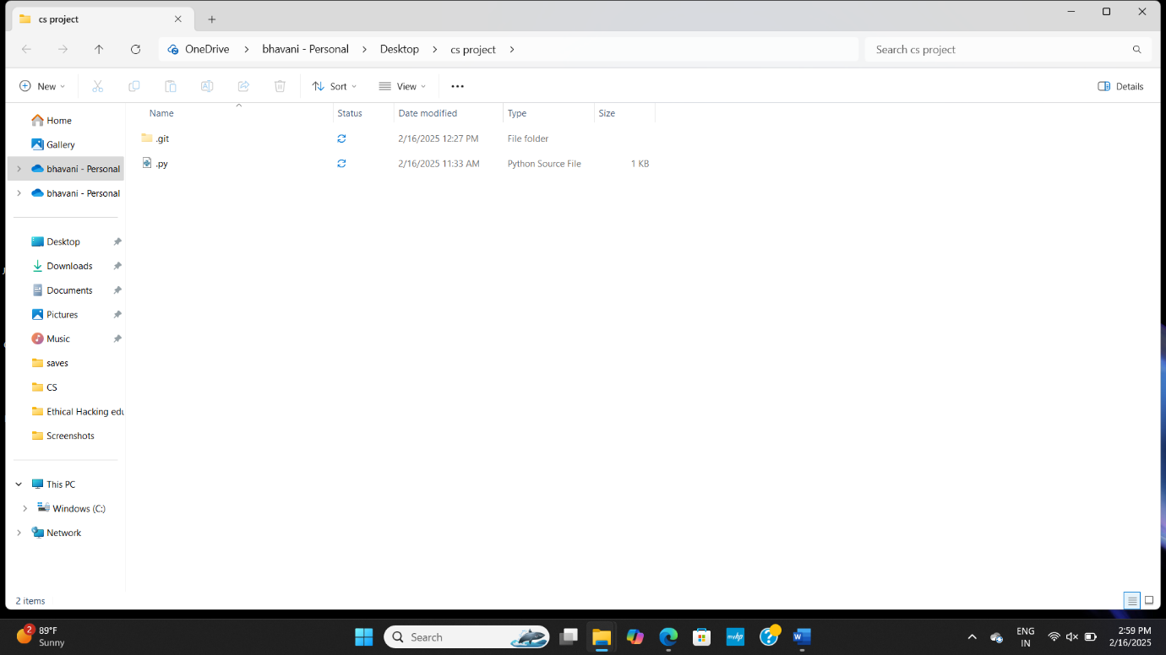

Creating file

Create the file in that folder as above shown picture python is created with extension of python

Opening terminal

Insatll VS code which is nothing but code editor . in vs code open terminal in that terminal initialize git by using the command **git init** by doing so git will be initialized on your vs code.

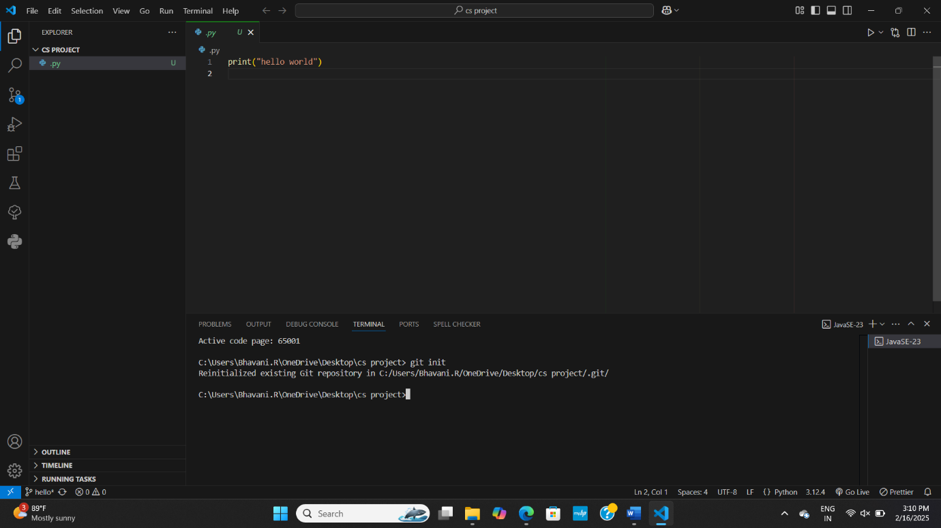

Git initialization

AS above shown by using the command **git init** I initialized git in terminal

Adding file to git

For adding file in git we should use command **git add .** this command is used to add a file in the folder

Adding new line to the git

For adding new line we should use command **git commit -m “hello world line”**  by using this command it says that we are adding new line to the file

Create a branch

Branch is a new/separate version of the main repository for doing this we use command **git commit -M “python”**

Establish a connection between git and github repository

To establish connection between git and github repository and to push the code into github. Command **git remote add origin “url”**



1. Now create a new branch to the repository

2. git branch -M Branch name

new branch will be created

3. git checkout Branch name

it is used to shift from one branch to onther branch

4. git clone “link”

another person’s repository fills and the folders will be loaded in your system

5. git fetch “link”

Details of the other person’s repository will be loaded